1create an empty directory ASSIGNMENTS2 AND CD ASSIGNMNETS2.

Created yesterday so I directly initialized



2.create a file Readme.txt inside Assignments & write few lines about the contents of Assignments folder.commit Readme.txt

33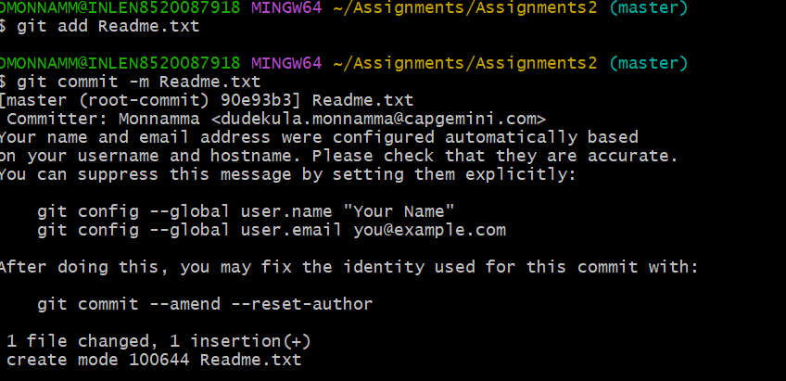

3.create a new branch html-assignments



4.switch to html-assignments



5.copy all html assignments inside Assignments2 folder and commit all html-assignments files

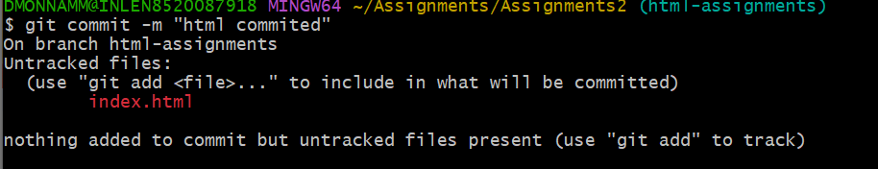

6.make minor changes into few lines belonging to html-assignments branch and commit the changes

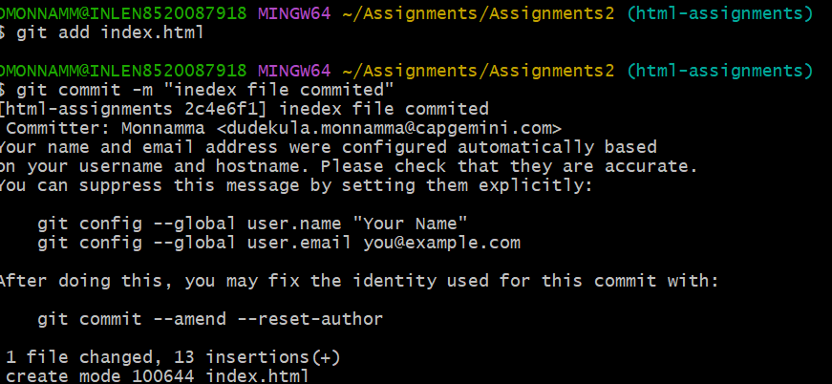

7.switch to master branch



8.make minor changes in Readme.txt file commit changes in master

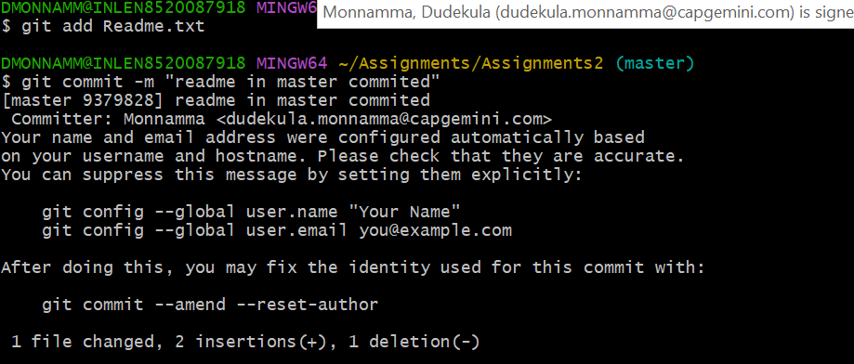

11.Again switch to html-assignments



12.make minor changes to few files belongs to html-assignments and commit

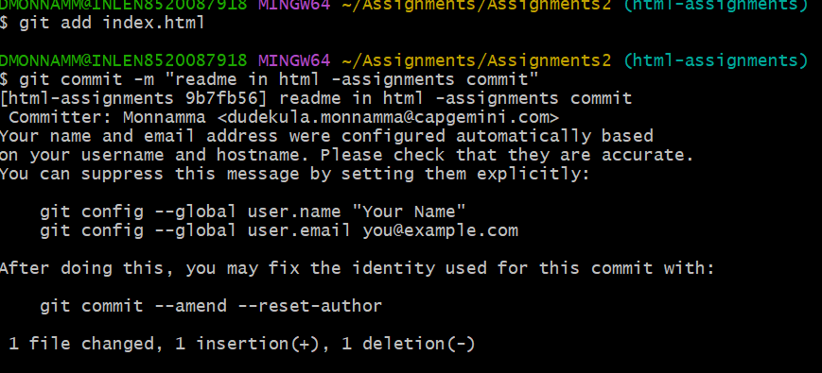

13.switch to master



14.merge html-assignments to master and confirm all html files in masterbranch

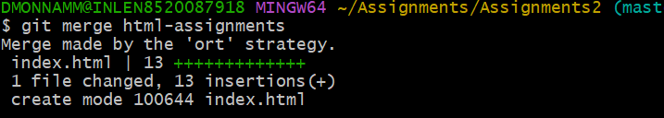

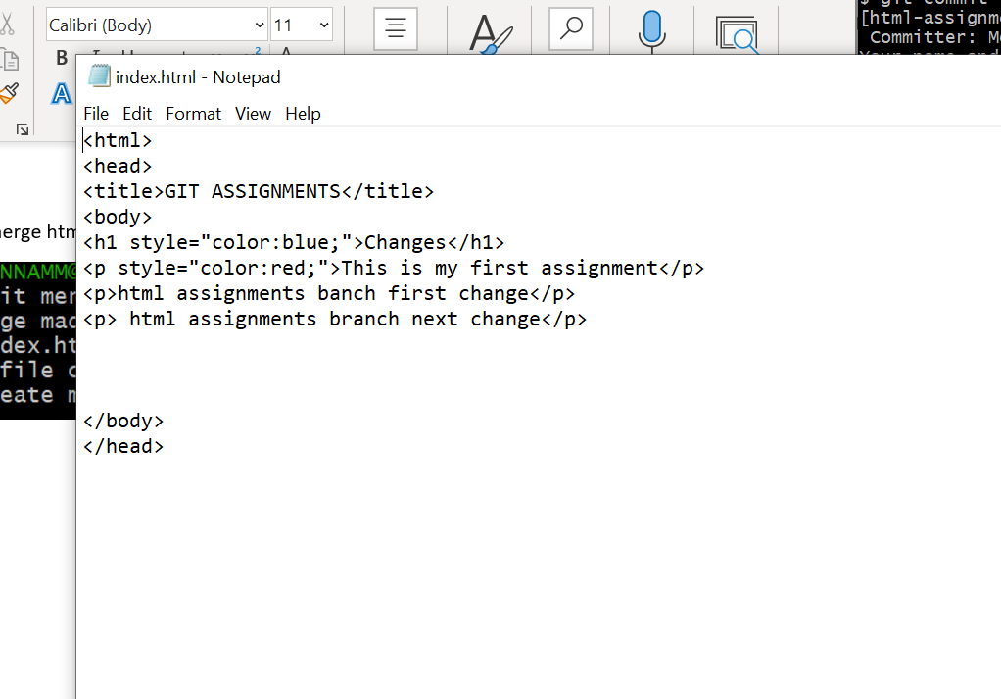

16.delete the html-assignmnets

